CHAPTER 8: Chemical change
Worksheet 8.3

Physical and chemical changes
Student: Class:

Classifying physical and chemical changes
1. Complete the following diagram by inserting words and phrases from each list below.
Types: physical changes, chemical changes
Characteristics: new substances form, no new substances form, little change in temperature, large change in temperature, often a change in colour, usually no change in colour, change is hard to reverse, change is easy to reverse
Examples: condensation, combustion, hard boil an egg, rusting, evaporation, melting gold
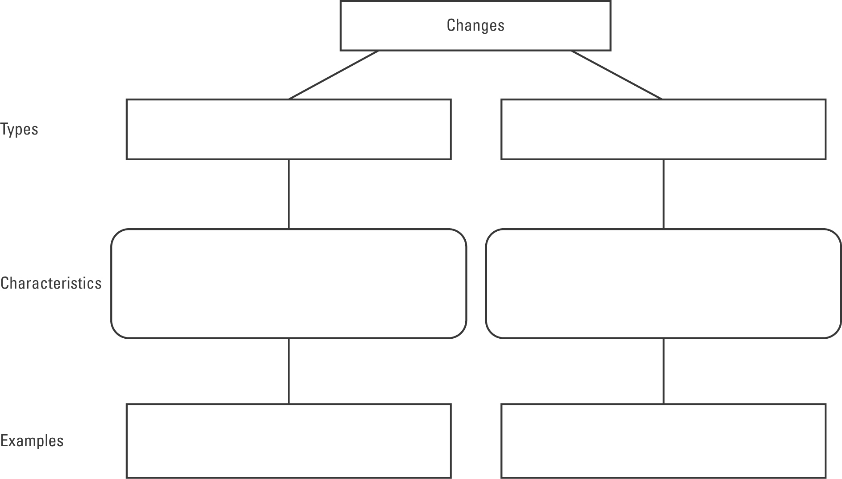

Visualising chemical changes
2. Models are very helpful in demonstrating chemical changes. In each example below determine whether the change involves synthesis of a new compound from its elements or decomposition of a compound into simpler compounds or elements. Write the words ‘synthesis’ or ‘decomposition’ in the spaces.
(a) (b)
